

EVR ATA CONFIGURATION MANUAL

Abisai Ngalande

Table of Contents
Features and Description. 3
Connections 3
Configuration 4
Entering connection details 4
1Select Quick Setup 4
2Click on Network Service Tab 4
3Network Settings 4

Features and Description.
Feature | Description | Comment
Reset | If pressed briefly it will reboot the ATA. Press and hold it will reset the device to factory default
Phone 1  Phone 2 | Using an RJ-11 phone cable connect to either one or both ports, connect to an analog phone.
Ethernet (Yellow) | Connect to computer, or the local network using Ethernet cable.
Internet (Blue) | Connect to a broadband network, or a route network.
DC 5VPower | Connect 5V power source using the right cable

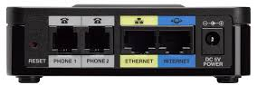
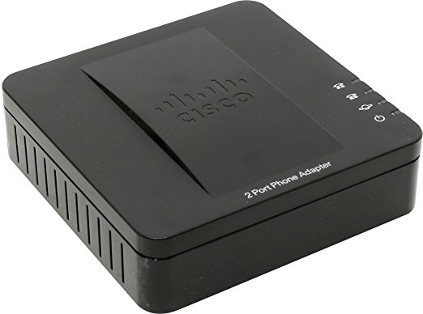

Connections
- Connect an analog phone to port 1.
- Connect computer to Ethernet port using Ethernet cable.
- Connect another Ethernet to the internet port and to the network on the other side
- Connect power cable.

Configuration
The computer will get an IP address from ATA, which will be 192.168.15.0 network.
- Log in the ATA using 192.168.15.1 through browser, this is default IP address.
- Enter username and password as admin

Entering connection details

Select Quick Setup
Line 1
- Proxy = 192.168.84.3
- Display Name = “Village name”
- Password = Mtema01
Line 2
Enter the same details as line 1

Click on Network Service Tab
- Click on a drop down menu and select “BRIDGE”
- Click submit to save

Network Settings
- Select static and enter
  - IP address 192.168.100.5
  - Netmask 255.255.255.0
  - Gateway 192.168.100.1
  - Host name “village’s name”
- Submit
Done

